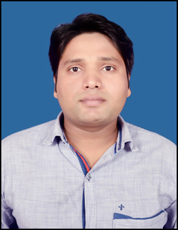 Chandan Chaurasia
Contact no. +91-8404809014
+91-7274820057 E-mail:cchaurasiabce@gmail.com

AT+Post- Neora
Distt – Patna (Bihar)
Pin Code - 801113

Objective | Seeking a position in the Technical industry, that enables me to use my technical skills and analytical abilities to achieve individual and organizational goals.
Professional Qualification | Done B.E, in ELECTRONICS & COMMUNICATION from Bansal College of Engineering affiliated to Rajiv Gandhi Technical University, Bhopal in 2015.
Education | Examination | Board/University | Specialization | Percentage/CGPA
Education | 10th | B.S.E.B. | Physics +Math +Science Stream | 59%
Education | 12th | B.I.E.C. | Physics + Chemistry + Math | 73%
 | B.E | R.G.P.V | E.C.E | 6.56
Technical skills | Operating Systems Windows 9x/2000/NT/XP, MS-DOS,  Windows Server 2003.  Languages MS Office  Packages
Summer Training | ALL INDIA RADIO,PATNA
Project Undertaken | - AUTOMATIC WATER LEVEL CONTROLLER  Using NE555
Seminars Attended / Presented | Attended Seminar “Embedded System & Robotics” by Dr. N.K.Tiwary at B.C.E. Bhopal.
Date Of Birth | 06th June 1992
Father’s Name | Ramjee Prasad Chaurasia
Marital Status | Single
Nationality | Indian
Hobbies | Listening Music, Net Surfing , Cricket , Chatting on social Network

Strength | A fire & passion to achieve something in life , Accepting challenges, Having an Optimistic attitude ,Believe in Spirituality, Punctuality, Believe in myself, Honesty.

I hereby declare that all the information provided here is correct to the best of my Knowledge.
Date: 15th Jun. 2016
Place: Patna (Chandan Chaurasia)

